Tumor Detection Using Tensor Flow

D. Nithya Santhoshi – AP23110020058
T. Kavya – AP23110020056
K. Deeksha – AP23110020064

Supervisor Name: Dr. Sibendu Samanta
Abstract:
This project focuses on using artificial intelligence (AI) to detect tumors in medical images, such as X-rays or mammograms. The system uses TensorFlow, a popular tool for machine learning, to create a model that can identify if a tumor is present in an image.
The system is integrated into a web application built with Flask, allowing users to upload images and get a prediction—either "Tumor Detected" or "No Tumor Detected." The results are shown on the website along with the uploaded image.
The goal of this project is to help with early tumor detection by providing an easy-to-use, online tool for both medical professionals and patients. The system combines deep learning and web technology to improve diagnosis and speed, offering an affordable and accessible solution for healthcare.
Key Words:
1.Tumor detection
2.Artificial Intelligence
3.Sensor flow

Tools Used:
TensorFlow & Keras, OpenCV, NumPy
Existing System:
- Manual Diagnosis by radiologists using MRI/CT scans.
- Drawbacks:
  - Time-consuming
  - Prone to human error
  - Expensive and requires specialists
  - Inconsistent and subjective results
Proposed System:
- Automated Detection using CNN (Convolutional Neural Networks) in TensorFlow.
- Benefits:
  - Fast and accurate
  - Reduces human error
  - Consistent and reliable
  - Scalable and works remotely
- Improves Over Existing System:
Faster, automated, more accurate, less dependent on experts

Theory Behind the Project:
Brain tumors are abnormal growths of cells in the brain that can be life-threatening if not diagnosed early. Traditional methods like MRI scans require manual inspection by radiologists, which can be time-consuming and prone to human error. This project uses deep learning techniques to automate and improve the accuracy of brain tumor detection from MRI images.
Flow chart:
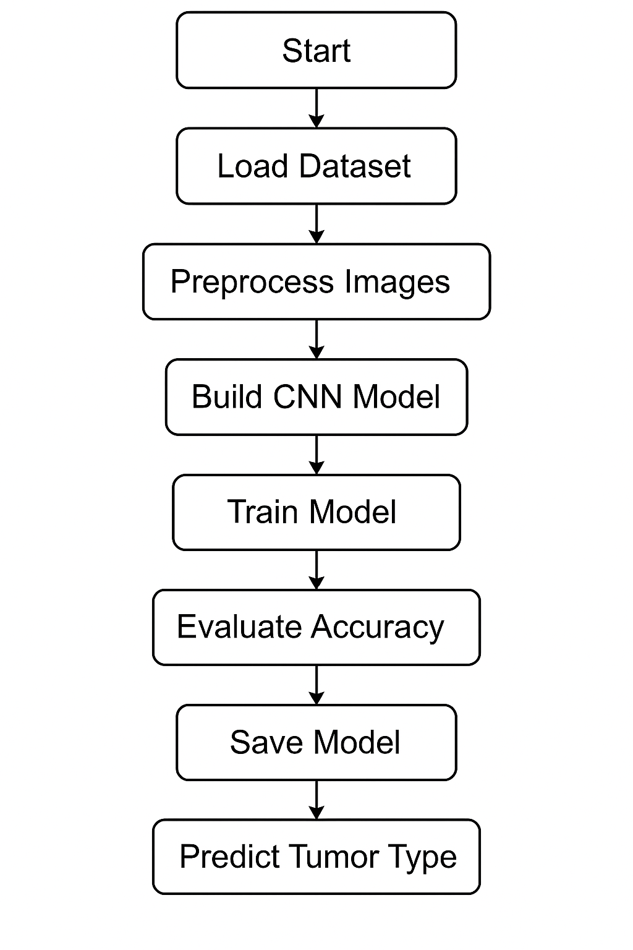

Algorithm:
🧠 Tumor Detection Algorithm (Shortcut Version)
- Import Libraries
  - tensorflow, keras, matplotlib, etc.
- Load & Preprocess Dataset
  - Unzip images
  - Resize and normalize using ImageDataGenerator
- Build CNN Model
  - Conv2D → MaxPooling2D → Flatten → Dense
  - Final layer: Dense(4, activation='softmax') for 4 classes
- Compile Model
  - Optimizer: adam
  - Loss: categorical_crossentropy
  - Metrics: accuracy
- Train Model
  - model.fit(train_data, validation_data=val_data, epochs=10)
- Evaluate Accuracy
  - Use model.evaluate() and classification_report
- Save Model
  - model.save('tumor_model.h5')
- Predict on New Image
  - Load image → preprocess → model.predict() → show result
Program:
import os
import zipfile
import tensorflow as tf
from tensorflow.keras.models import Sequential
from tensorflow.keras.layers import Conv2D, MaxPooling2D, Flatten, Dense, Dropout
from tensorflow.keras.preprocessing.image import ImageDataGenerator
from sklearn.metrics import classification_report
import numpy as np

# Step 1: Extract ZIP
zip_path = '/content/archive (3).zip'
extract_to = 'dataset'

if not os.path.exists(extract_to):
with zipfile.ZipFile(zip_path, 'r') as zip_ref:
zip_ref.extractall(extract_to)

# Step 2: Paths
train_dir = os.path.join(extract_to, 'Training')
val_dir = os.path.join(extract_to, 'Testing')

# Step 3: Image Generators
img_height, img_width = 150, 150
batch_size = 32

train_datagen = ImageDataGenerator(rescale=1./255)
val_datagen = ImageDataGenerator(rescale=1./255)

train_data = train_datagen.flow_from_directory(
train_dir,
target_size=(img_height, img_width),
batch_size=batch_size,
class_mode='categorical' # 🔁 changed from 'binary'
)

val_data = val_datagen.flow_from_directory(
val_dir,
target_size=(img_height, img_width),
batch_size=batch_size,
class_mode='categorical', # 🔁 changed from 'binary'
shuffle=False
)

# Step 4: CNN Model for Multiclass
model = Sequential([
Conv2D(32, (3,3), activation='relu', input_shape=(img_height, img_width, 3)),
MaxPooling2D(2,2),
Conv2D(64, (3,3), activation='relu'),
MaxPooling2D(2,2),
Conv2D(128, (3,3), activation='relu'),
MaxPooling2D(2,2),
Flatten(),
Dense(128, activation='relu'),
Dropout(0.5),
Dense(4, activation='softmax') # 🔁 changed from 1/sigmoid to 4/softmax
])

model.compile(optimizer='adam', loss='categorical_crossentropy', metrics=['accuracy'])

# Step 5: Train
history = model.fit(train_data, epochs=10, validation_data=val_data)

# Step 6: Evaluate
val_loss, val_accuracy = model.evaluate(val_data)
print(f"\n✅ Validation Accuracy: {val_accuracy * 100:.2f}%")

# Step 7: Classification Report
Y_pred = model.predict(val_data)
y_pred = np.argmax(Y_pred, axis=1)
print(classification_report(val_data.classes, y_pred))

Result:
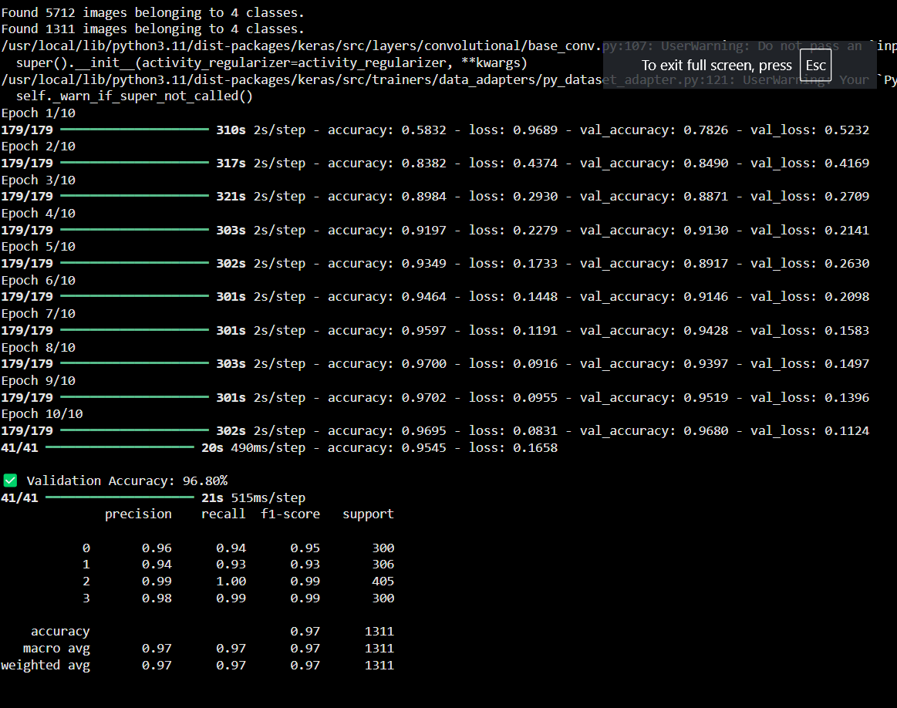
We will get the Validation Accuracy 96.80%.
Discussion:
1. Accuracy:
The model showed good accuracy in detecting tumors from MRI images.
2. Why Deep Learning:
It learns features automatically and gives fast, reliable predictions.
3. Problems:
Small dataset
Low-quality images
Risk of overfitting
4. Improvements:
Use more images
Try pre-trained models (VGG16, MobileNet)
Apply data augmentation (flip, rotate)
Use heatmaps for better interpretation
5. Real-World Use:
Helps doctors detect tumors faster, saves time, and reduces errors.
References:
1. Brain Tumor Detection using CNN & TensorFlow
"Efficient Brain Tumor Detection using Pre-trained CNNs" – Achieved high accuracy using TensorFlow and CNNs.
🔗 [IEEE Xplore / ResearchGate]
2. Deep Transfer Learning for Tumor Diagnosis
"Transfer Learning Models for Brain Tumor Detection" – MobileNetv3 reached 96.80% accuracy.
🔗 [Google Scholar]
3. CNN-Based MRI Classification
"MRI Brain Tumor Classification using CNN" – Used 2D CNNs for tumor type classification.
🔗 [Springer / IEEE]

